
GOVT COLLEGE OF TECHNOLOGY FOR WOMAN SAHIWAL

PROJECT PROPOSAL

“ONLINE LEARNING MANAGEMENT SYSTEM”

SUBMITTED TO :
MAM SHAGUFTA SHARIF

SUBMITTED BY :
JANNAT FATIMA (LEADER)
IQRA ZUBAIR
SADIA IFTIKHAR
IMAN FATIMA
SUMAN MUBEEN
MUNAZZA HARMAN

CONTENTS

- Introduction
- Project Overview
- Objectives
- Scope
- Requirements
- Methodology
- System Design
- DFD
- ER Diagram
- Components
- Tools & Technologies
- Project Procedure
- Advantages
- Disadvantages
- Expected Results
- Conclusion

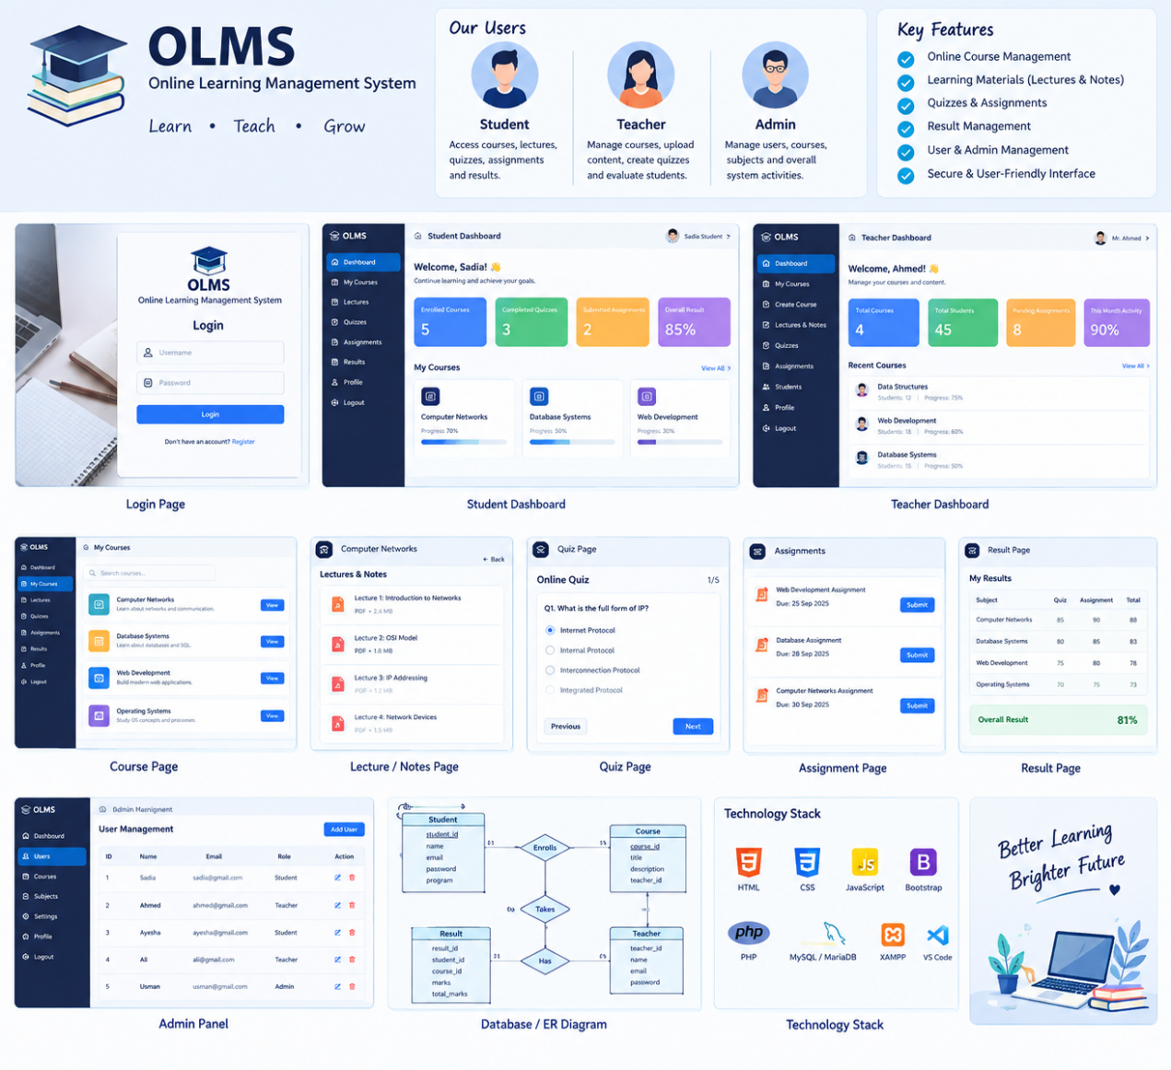

INTRODUCTION

- Online Learning Management System (OLMS) is a web- based platform designed for digital education.
- It provides a centralized platform for students, teachers, and administrators.
- Students can access courses, lectures, notes, quizzes, assignments, and results.
- Teachers can create courses, upload learning materials, manage quizzes, and evaluate assignments.
- Administrators can manage users, courses, subjects, and overall system activities.
- The system aims to make learning organized, accessible, flexible, and user-friendly.
PROJECT OVERVIEW

- OLMS is a web-based platform developed to provide a simple, organized, and accessible online learning environment.
- The system connects three main users: Students, Teachers, and Admin.
- Students can register, enroll in courses, access lectures and notes, attempt quizzes, submit assignments, and view results.
- Teachers can create courses, upload learning materials, manage quizzes and assignments, check submissions, and give marks.
- Admin can manage students, teachers, courses, subjects, and overall system activities.
- The project uses HTML, CSS, JavaScript, Bootstrap, PHP, MySQL/MariaDB, and XAMPP.
- DFD and ER diagrams are used to represent the system flow and database relationships.
- The system aims to reduce paperwork, save time, organize academic records, and make learning more flexible and user-friendly.
- Overall, OLMS provides a centralized digital platform for learning, teaching, assessment, and academic management.

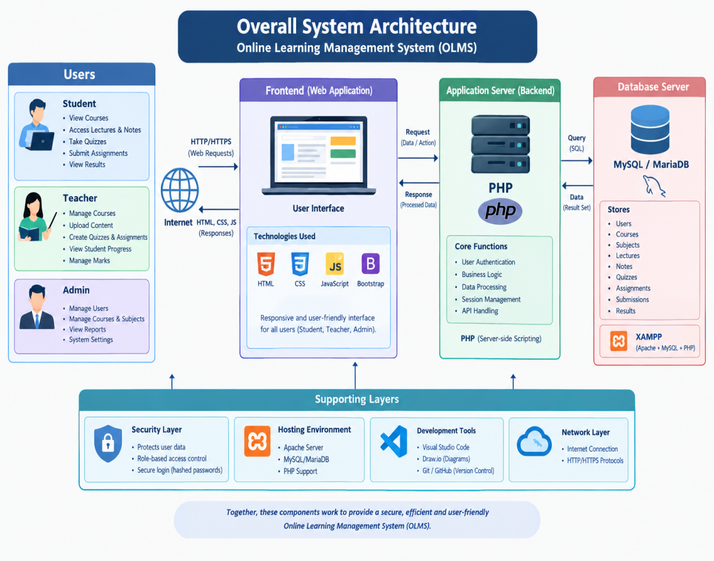

OBJECTIVES

- To provide online access to courses, lectures, and study materials.
- To allow teachers to upload and manage educational content.
- To enable students to attempt quizzes and submit assignments online.
- To maintain student marks, results, and academic records.
- To provide admin with complete control over students, teachers, and courses.
- To make the learning process simple, organized, and accessible online.

PROJECT COVERAGE / SCOPE

- Student Management – Registration, login, profiles, course enrollment, and learning activities.
- Teacher Management – Course creation, content uploading, quizzes, assignments, and student evaluation.
- Admin Management – Management of students, teachers, courses, subjects, and system activities.
- Course Management – Creating, updating, and accessing online courses.
- Learning Materials – Providing lectures, notes, and other study resources.
- Online Assessment – Quizzes, assignments, submissions, and marks.
- Result Management – Recording and displaying students’ academic results.
- Database Management – Secure and organized storage of system information.
- Future Expansion – Live classes, notifications, certificates, and mobile application support can be added later.

PROJECT REQUIREMENTS

- User Authentication – Registration and secure login for students, teachers, and admin.
- Course Management – Create, manage, and access online courses and subjects.
- Learning Materials – Upload and access lectures, notes, and study resources.
- Online Assessment – Conduct quizzes and manage assignments and submissions.
- Result Management – Record, calculate, and display student marks and results.
- Admin Management – Manage users, courses, subjects, and system activities.
- Database Management – Store and retrieve all project information using MySQL/MariaDB.
- User-Friendly & Secure System – Provide easy navigation, reliable performance, and basic data security.

METHODOLOGY
- Requirement Analysis
Identify the needs of Students, Teachers, and Admin and define the system features and requirements.
- System Design
Design the overall system structure using DFD, ER Diagram, system flow, and module design.
- Database Design
Create and organize database tables for users, courses, lectures, quizzes, assignments, submissions, enrollments, and results.
- UI / Frontend Development
Design user-friendly pages such as Login, Registration, Dashboards, Courses, Quiz, Assignment, and Result pages.
- Back-end Development
Develop the system functionality using PHP, including authentication, course management, quizzes, assignments, and result management.
- System Integration
Connect the front-end, PHP back-end, and MySQL/MariaDB database using XAMPP.
- Testing & Debugging
Test all major functions, identify errors, and fix problems to ensure the system works correctly.
- Deployment & Documentation
Set up the final working system, prepare project documentation, screenshots, presentation, and final demonstration.
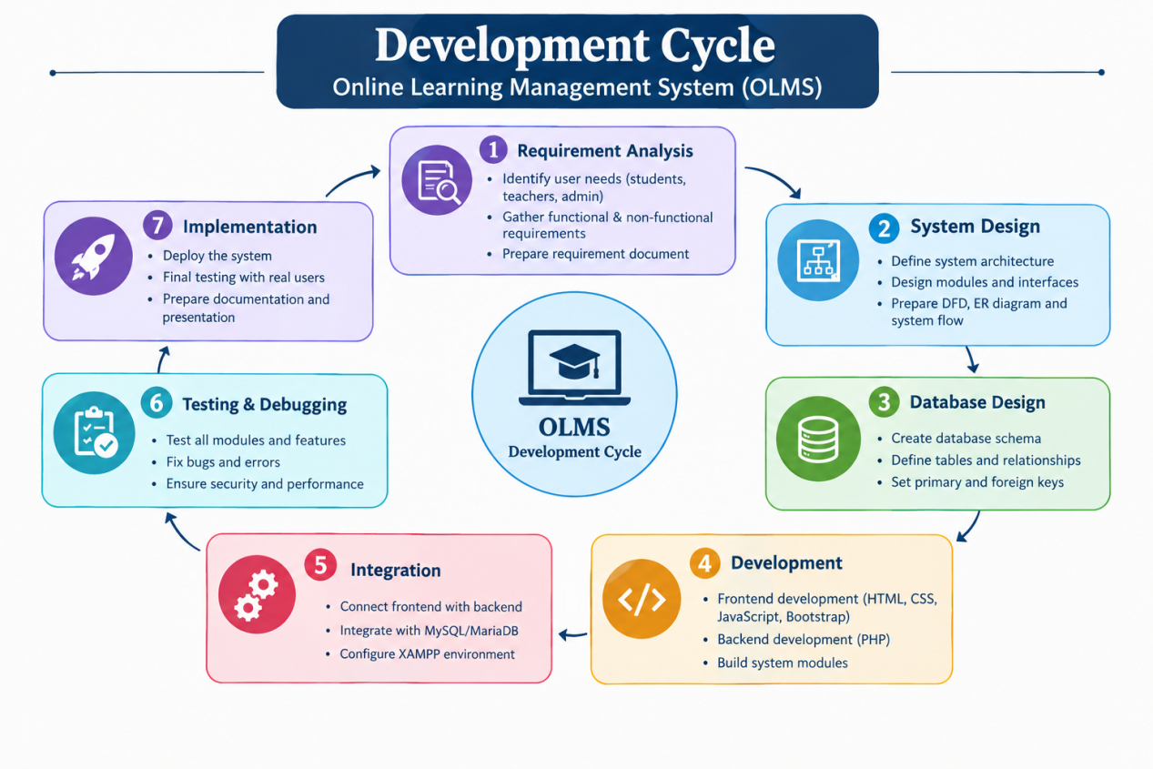

Online Learning Management System (OLMS)

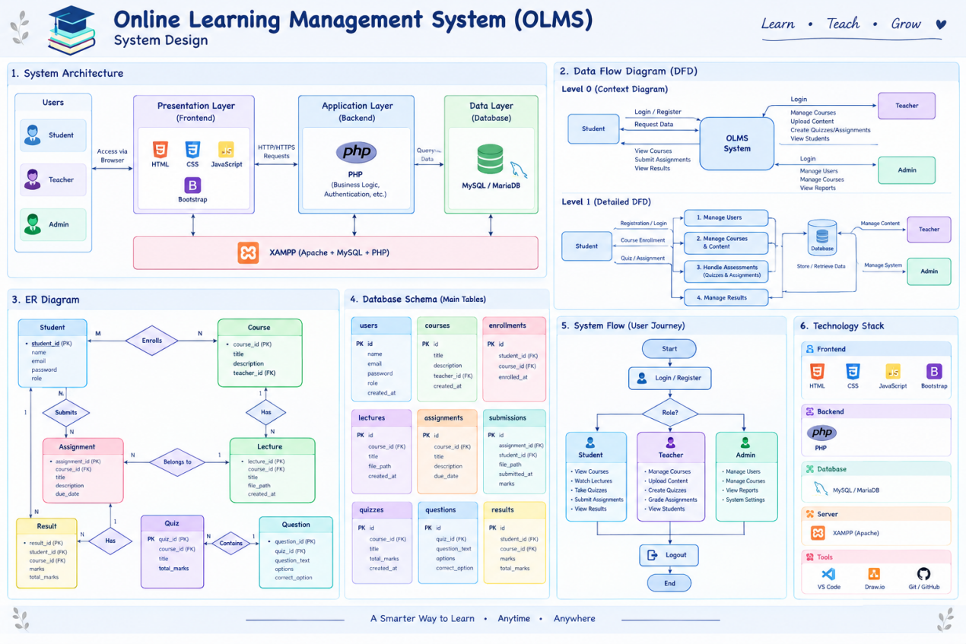

DFD DIAGRAM (DATA FLOW DIAGRAM)

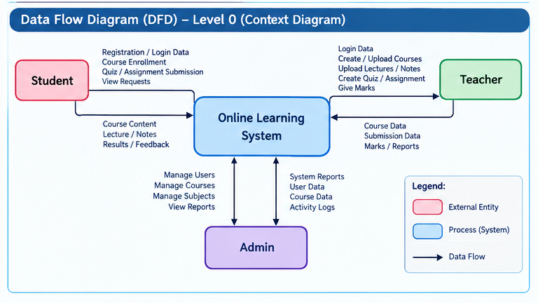

ER DIAGRAM (ENTITY RELATIOONSHIP DIAGRAM)

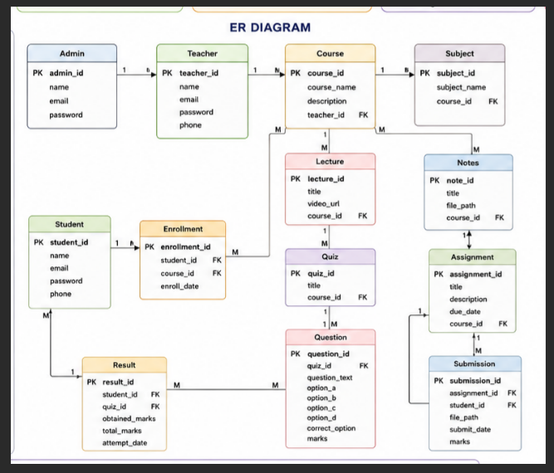

COMPONENTS
- Admin Component – Manages students, teachers, courses, subjects, and reports.
- Student Component – Handles registration, courses, lectures, quizzes, assignments, and results.
- Teacher Component – Manages courses, lectures, notes, quizzes, assignments, and student marks.
- Course Component – Manages course information, subjects, lectures, notes, and assessments.
- Quiz Component – Handles quiz questions, options, answers, marks, and results.
- Assignment Component – Manages assignments, due dates, student submissions, and marks.
- Database Component – Stores users, courses, enrollments, lectures, quizzes, assignments, submissions, and results.
- Authentication Component – Provides registration, login, logout, and role-based access.
- Result Component – Records and displays students’ marks and academic results.
- User Interface Component – Provides dashboards and pages for Admin, Teacher, and Student.
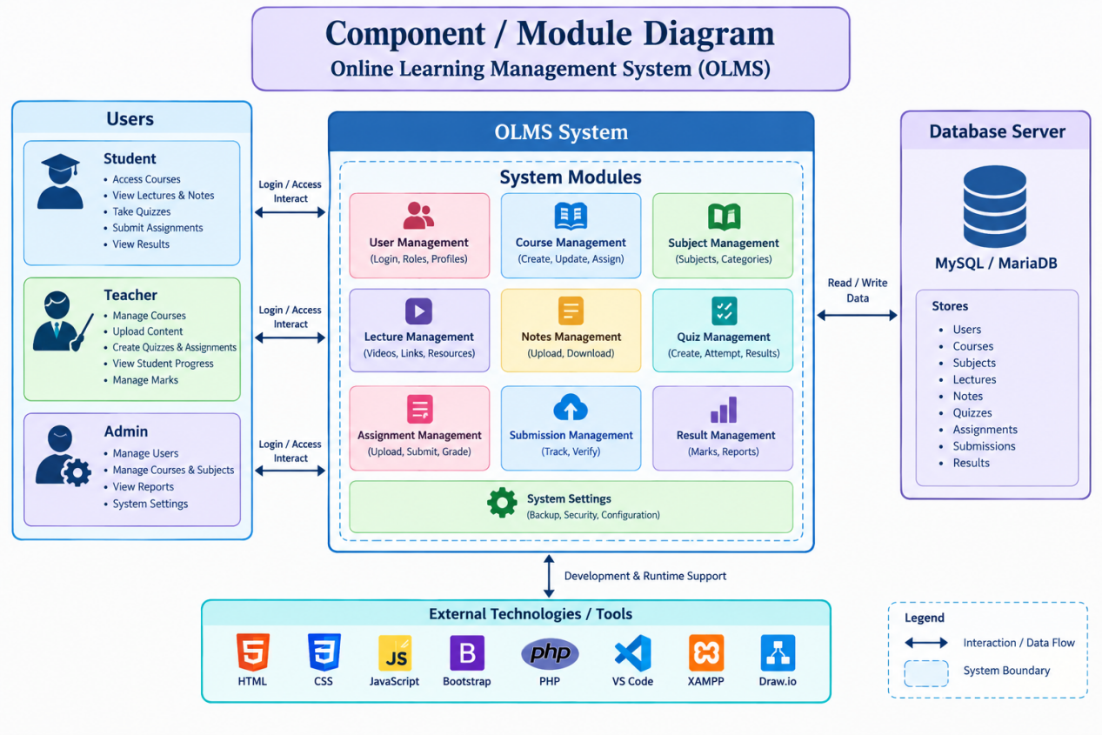

TOOLS
- Visual Studio Code – Code development
- XAMPP – Local server environment
- Apache – Web server
- PHP – Back-end development
- MySQL / MariaDB – Database management
- HTML – Webpage structure
- CSS – Webpage styling
- JavaScript – Interactive features
- Bootstrap – Responsive UI design
- Draw.io – DFD and ER diagram design
- Git / GitHub – Version control
- Chrome / Edge – Testing and preview

⚙️ TECHNIQUES
- Requirement Analysis
- System Design
- DFD Modeling
- ER Modeling
- Database Normalization
- Modular Development
- Frontend & Backend Integration
- Database Integration
- Testing & Debugging
- Role-Based Access Control
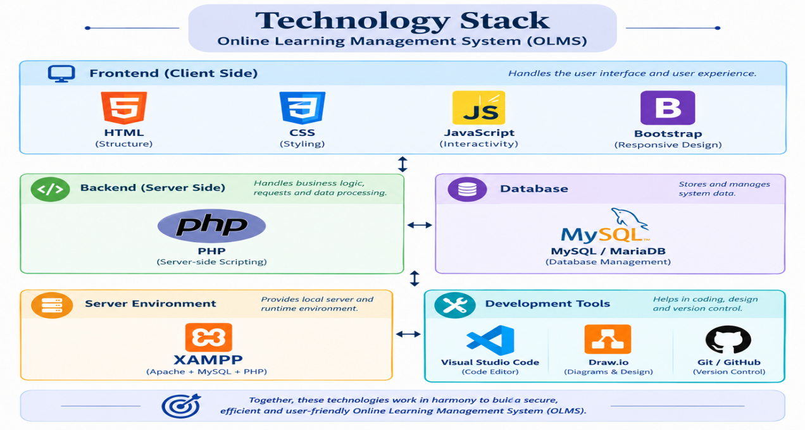

PROCEDURE

- Start the System – The user opens the OLMS website/application.
- User Authentication – The user enters their username and password to log in.
- Credential Verification – The system verifies the login information. Invalid credentials generate an error message and return the user to the login page.
- Role Identification – After successful authentication, the system identifies whether the user is a Student, Teacher, or Admin.
- Role-Based Operations – The user is directed to the appropriate dashboard and performs authorized activities.
- Student Activities – Students can enroll in courses, access lectures and notes, attempt quizzes, submit assignments, and view results.
- Teacher Activities – Teachers can manage courses, upload lectures and notes, create quizzes and assignments, evaluate submissions, and manage student marks.
- Admin Activities – Admin manages users, courses, subjects, reports, and system settings.
- Data Processing & Storage – All activities are processed by the system and relevant information is stored or retrieved from the MySQL/MariaDB database.
- Session Completion – After completing their activities, users log out of the system and the session ends.

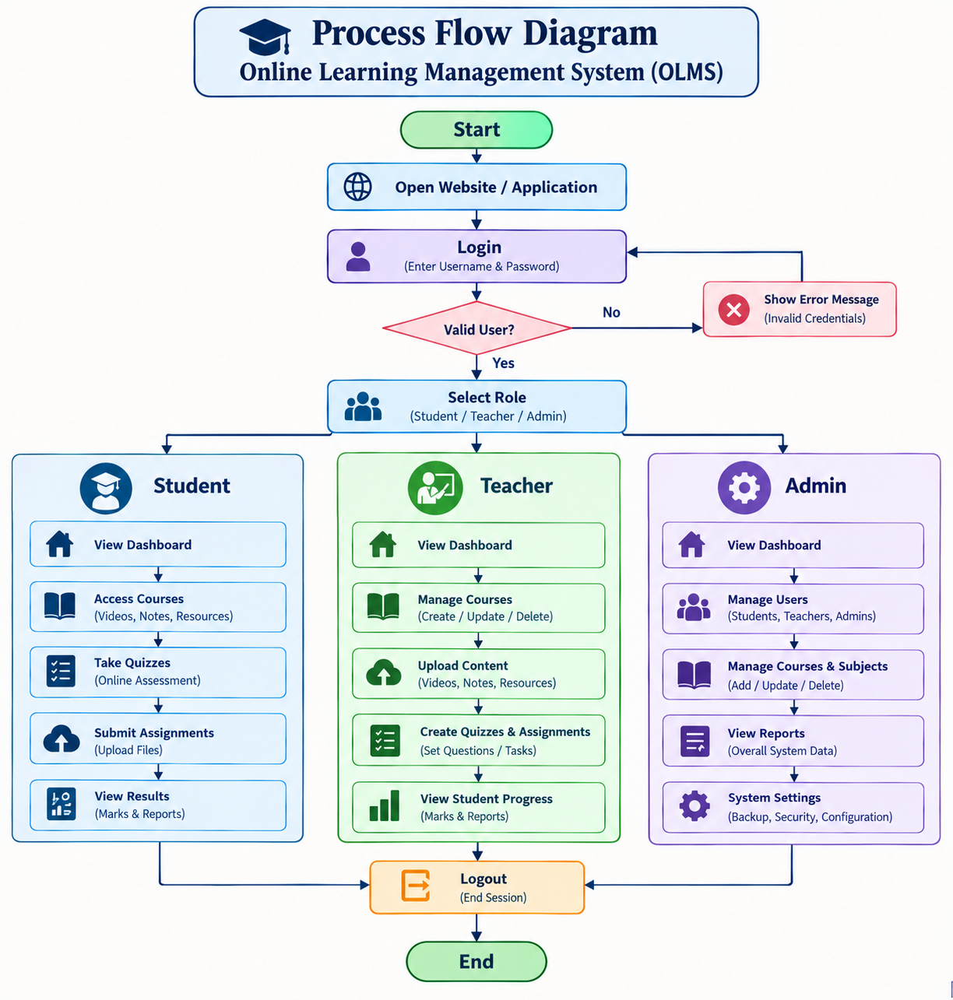

ADVANTAGES
- Easy Online Learning – Students can access courses and study materials easily.
- Centralized System – Learning activities are managed in one platform.
- Time Saving – Reduces paperwork and manual processes.
- Easy Content Management – Teachers can upload and manage educational material.
- Online Assessment – Quizzes and assignments can be conducted digitally.
- Better Record Management – Student marks and results are stored systematically.
- User-Friendly – Separate interfaces make the system easy to use.

DISADVANTAGES
- Internet Dependency – Some online features require an internet connection.
- Technical Issues – Server or database problems may affect system availability.
- Security Risks – User information requires proper protection.
- Limited Physical Interaction – Online learning cannot completely replace face-to-face interaction.
- Maintenance Required – The system needs regular updates and maintenance.

EXPECTED RESULT
- A working Online Learning Management System for students, teachers, and admin.
- Students will be able to access courses, lectures, notes, quizzes, assignments, and results.
- Teachers will be able to manage courses and educational content.
- Admin will be able to manage users, courses, subjects, and reports.
- The system will provide organized database storage for academic information.
- The project will make the learning and management process more organized, accessible, and efficient.

CONCLUSIONS
- OLMS provides a centralized platform for online learning and academic management.
- It connects students, teachers, and administrators in one system.
- Students can easily access courses, lectures, notes, quizzes, assignments, and results.
- Teachers can efficiently manage courses, educational content, assessments, and student performance.
- Admin can manage users, courses, subjects, and overall system activities.
- The system helps save time, reduce paperwork, and organize academic records.
- OLMS provides a simple, flexible, and user-friendly digital learning environment.
- The project can be further improved with live classes, notifications, certificates, and mobile app support.

